SPRINT-1

|  |  |
| --- | --- |
| **TEAMID** | **PNT2022TMID08727** |
| **PROJECTNAME** | **IOTBASEDSMARTCROPPROTECTIONSYSTEM**  **FORAGRICULTURE.** |
| **MAXMARKS** | **20MARKS** |

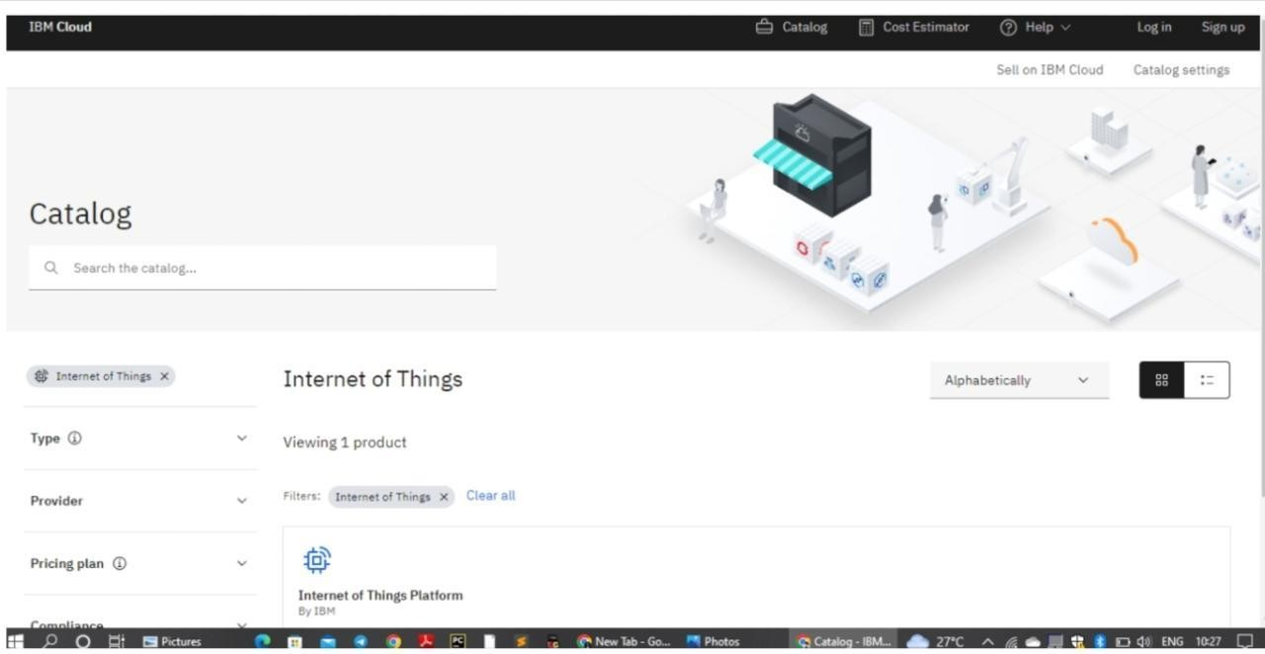

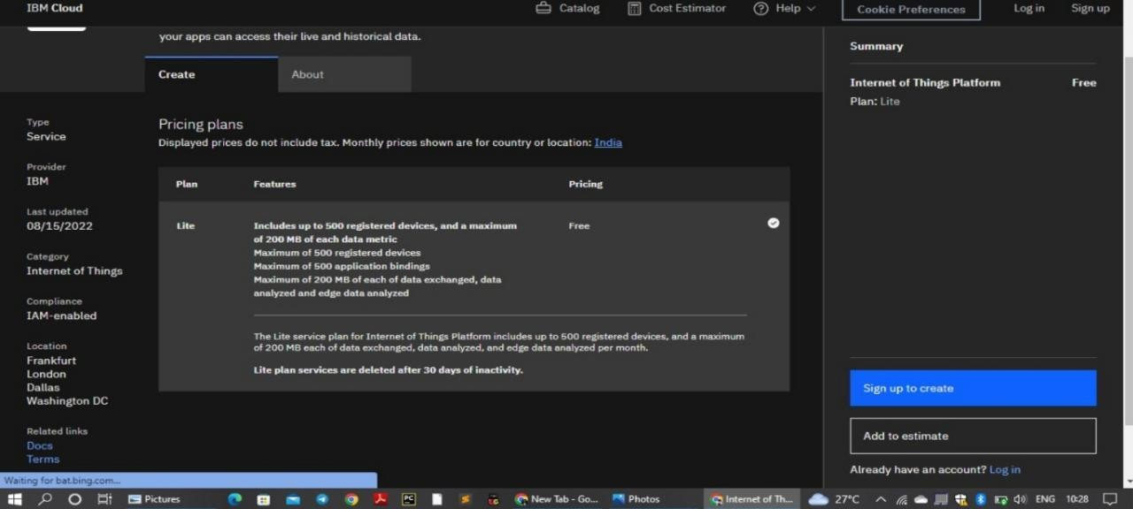

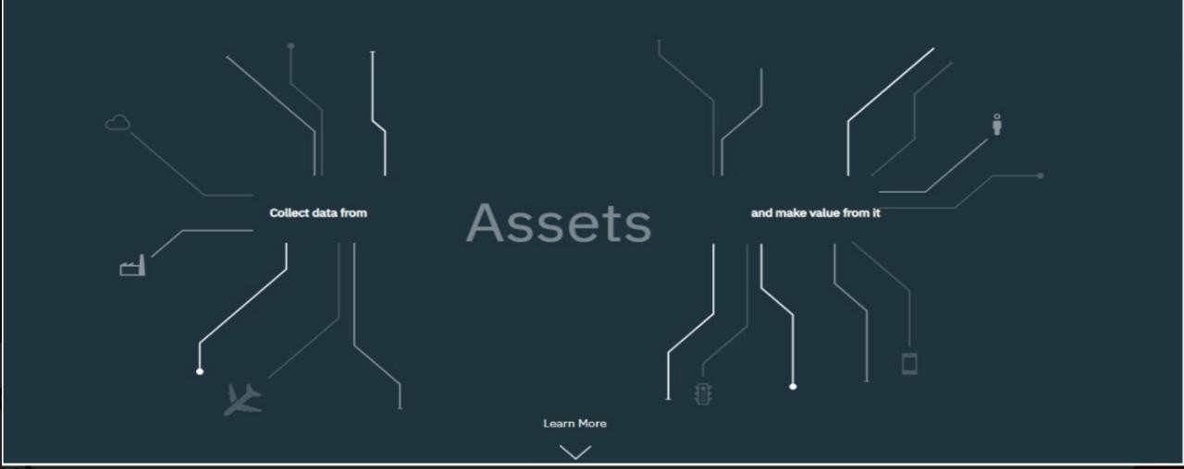

DEVICECREDENTIALSINFORMATION:

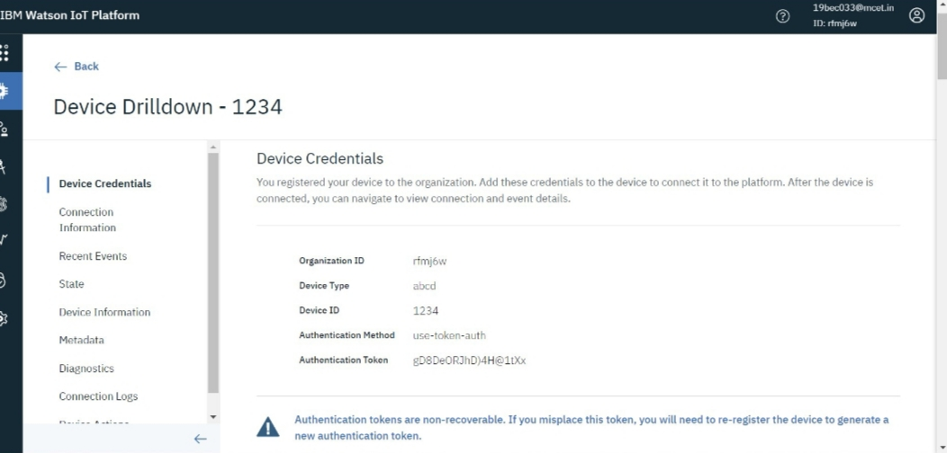

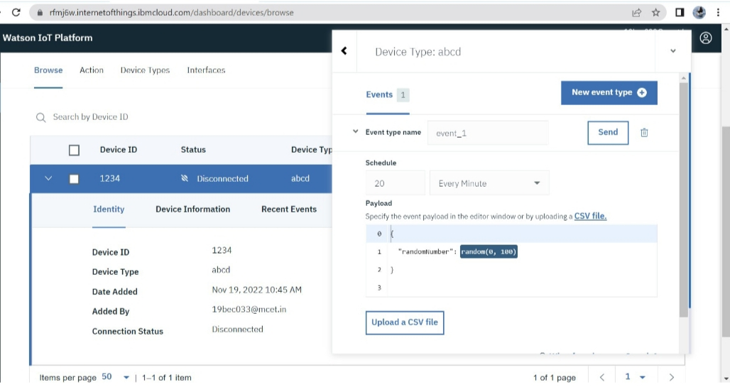

OUTPUT:

